Thesis for Lexicography and Generative AI

Mapping the Lexicon of Hate: Offensive Language Structure in Korean Online Discourse

Seeon Kim

Computational Linguistics
University of Tübingen

2026

Contents

Abstract 4
1. Introduction 5

2.Dataset: KOLD 5
1) Data Collection 5
2) Annotation Framework and Quality 5
3) Context and Cultural Specificity 5
3. Q1. Who Is Attacked? Target Group Distribution 6
1) Offensive language distribution 6
2) Target type distribution 7
3) Group distribution 8

4. Q2. Which Groups Are Attacked Together? Co-targeting Network Analysis 9
1) Network Construction 10
2) Node level analysis 11
3) Edge level analysis 11
4) Cluster analysis 13
5. Q3. How Are They Attacked? Target-Specific Offensive Framing 14
1) Why not simple lexicon analysis? 14
2) Token extraction and pattern discovery 15
3) Concept taxonomy abstraction 16

6. Conclusion 18
7. References 20

Abstract

Mapping the Lexicon of Hate: Offensive Language Structure in Korean Online Discourse

by Se eon Kim
Computational Linguistics
University of Tübingen

This study examines the structure of offensive language in Korean online discourse using the KOLD dataset (40,429 comments from NAVER and YouTube). Through three layers of analysis — target group distribution, co-targeting network analysis, and offensive framing patterns — we identify three key characteristics of Korean offensive discourse. First, ideology-based groups are attacked more frequently than identity-based ones, departing markedly from English-language datasets. Second, gender functions as a structural axis connecting multiple conflict domains rather than a single category. Third, attack frames are target-specific: ideological groups are pathologized, ethnic minorities are framed as outsiders, gender groups are attacked through role stereotypes, and religious groups are ideologized or demonized. These findings reveal that Korean offensive language is a structured system of framing strategies shaped by Korea's specific sociopolitical context.

Key words
offensive language, hate speech, Korean online discourse, lexical framing, target-specific framing, co-targeting network, pathologization, outsider framing, gender conflict, sociopolitical context
- Introduction
Language is not a neutral medium. It reflects the beliefs and conflicts of the society that produces it. Offensive language makes this particularly visible: attacks are rarely random, but structured around shared social tensions. In Korea, where gender conflict and ideological division are especially pronounced, online comments serve as a direct window into these fault lines.
What drew us to this dataset was not the profanity itself, but what lies beneath it. Just as emotions leak through tone and indirection rather than explicit statement, social conflict leaves structural traces in language that surface-level analysis cannot fully capture. Offensive language, we suspected, follows hidden patterns, not just who is attacked, but how, and through what conceptual frames.
This paper examines those patterns using the KOLD dataset, a Korean offensive language corpus of 40,429 comments collected from NAVER and YouTube. The analysis proceeds through three progressively deeper questions: who is attacked (target group distribution), which groups are attacked together (co-targeting network analysis), and how they are attacked (offensive framing patterns). Together, these three questions reveal the structural and lexical organization of offensive discourse in Korean online spaces.

- Dataset: KOLD
1) Data Collection
KOLD (Korean Offensive Language Dataset) comprises 40,429 comments collected from NAVER news and YouTube between March 2020 and March 2022 (Jeong et al., 2022). Since offensive comments are scarce in general online discourse, data was collected using a keyword-based strategy targeting offense-prone contexts across domains including gender, race, religion, and politics. Article and video titles were collected alongside comments to serve as contextual information during annotation.

2) Annotation Framework and Quality

KOLD uses a three-level hierarchical annotation framework. Level A identifies whether a comment is offensive and marks the offensive span — the minimal text segment justifying the offensiveness, including implicit expressions, sarcasm, and emojis. Level B categorizes the target type (untargeted, individual, group, or other) with a corresponding target span. Level C identifies the specific target group from 21 culturally grounded categories, organized under five attributes: Gender & Sexual Orientation, Race/Ethnicity/Nationality, Political Affiliation, Religion, and Miscellaneous. Multi-group annotation is permitted where applicable. Annotation was conducted by 3,124 crowdsourced workers who passed a qualification test, with an inter-annotator agreement of Krippendorff's α = 0.55.

3) Context and Cultural Specificity
A key characteristic of KOLD is that 55.1% of group-targeted comments contain no explicit target span; the target is often implicit and only identifiable through the article title. This reflects a broader point: offensive language is culture- and language-dependent. KOLD's target group distribution differs substantially from English datasets such as HateXplain, where African and Jewish communities top the rankings. In KOLD, feminist ranks first, followed by LGBTQ+ and Women, with groups such as Korean-Chinese, Progressive, and Conservative appearing exclusively in the Korean context. These motivates a language-specific analysis rather than cross-lingual transfer.

- Q1. Who Is Attacked? Target Group Distribution
We begin by examining the overall distribution of offensive language in the KOLD dataset, asking three progressively narrower questions: how much offensive language exists, who it targets, and which specific groups are most frequently attacked.
- Offensive language distribution

Figure 1. Distribution of offensive and non-offensive comments in KOLD (N=40,429).

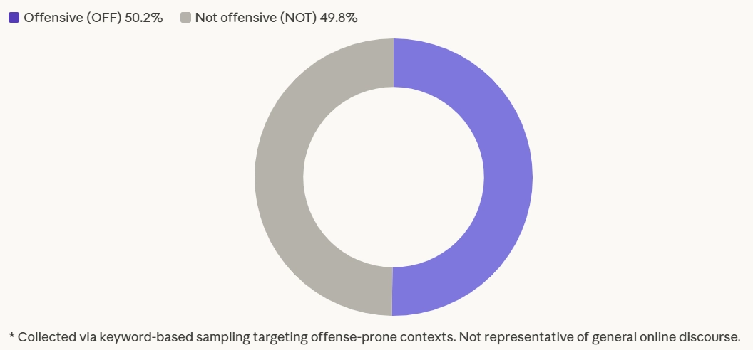
Among the 40,429 comments in KOLD, 50.2% are classified as offensive. However, given that the dataset was constructed through keyword-based sampling targeting offense-prone contexts, this figure should not be interpreted as representative of general online discourse. Rather, it reflects the prevalence of offensive language within contexts where such language is likely to occur.
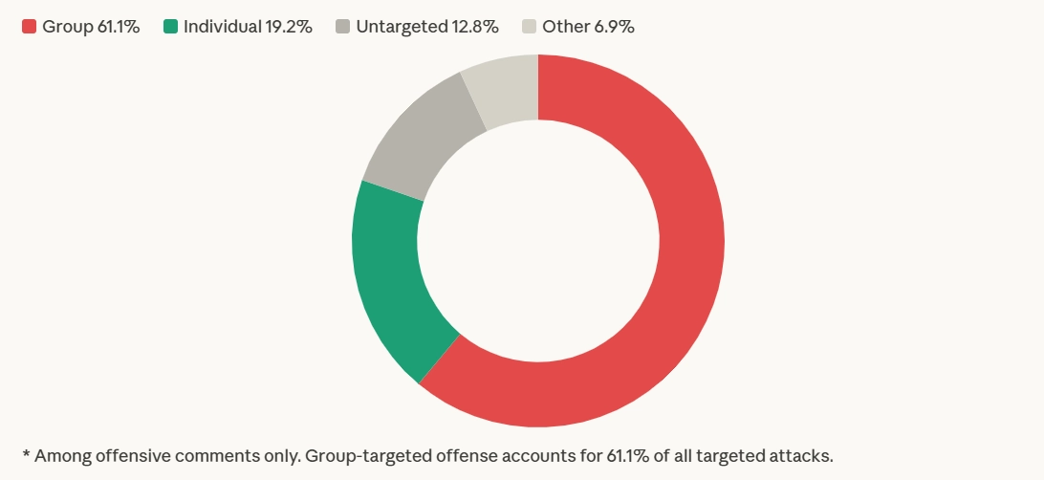
2) Target type distribution

Figure 2. Target type distribution among offensive comments.

Among offensive comments, 61.1% are group-targeted (GRP), far exceeding attacks on individuals (19.2%), untargeted profanity (12.8%), and other targets (6.9%). This indicates that offensive language in Korean online discourse is predominantly directed at social groups rather than specific individuals.
3) Group distribution
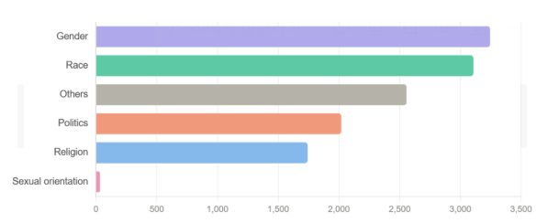
Figure 3. Target group attribute distribution (group-targeted offensive comments only)

At the attribute level, gender (3,245) and race (3,107) are the most frequently targeted categories, followed by others (2,557), politics (2,019), and religion (1,742). Sexual orientation appears far less frequently (33), though it re-emerges at the group level through LGBTQ+ and homosexual.
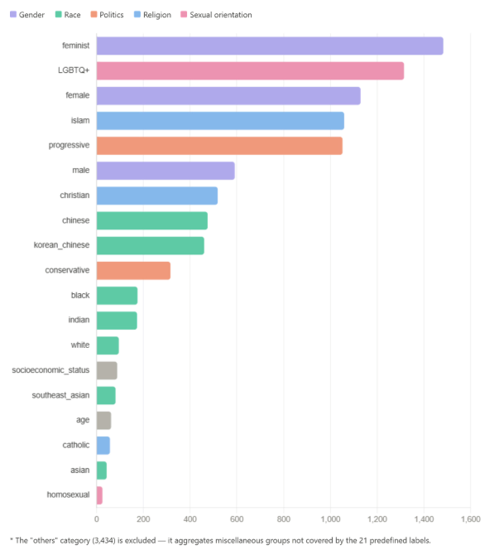
Figure 4. Target group distribution, excluding the "others" category.

At the group level, feminist ranks first (1,483), followed by LGBTQ+ (1,315), female (1,129), islam (1,059), and progressive (1,052). This reveals two distinct axes of attack: identity-based targets such as female, chinese, and islam, and ideology-based targets such as feminist, progressive, and conservative. Notably, feminist — classified under Miscellaneous rather than Gender, as it represents an ideological group rather than a biological category — tops the ranking, reflecting the prominence of gender-ideological conflict in Korean online discourse. The others category (3,434) aggregates comments targeting groups not covered by the 21 predefined labels — including North Korean defectors, Afghans, and other minority groups — and is excluded from further qualitative interpretation.
However, frequency-based EDA only reveals who is attacked most often. It does not capture which groups are attacked together. To address this, the next analysis employs co-targeting network analysis to examine how different target groups interact within offensive discourse.
- Q2. Which Groups Are Attacked Together? Co-targeting Network Analysis
We construct a co-targeting network to examine how target groups relate to one another within offensive discourse. The analysis proceeds in four steps: network construction, node-level centrality analysis to identify structural hubs, edge-level analysis to uncover the most frequent co-target pairs, and clustering to reveal broader community structures within the network.

1) Network Construction
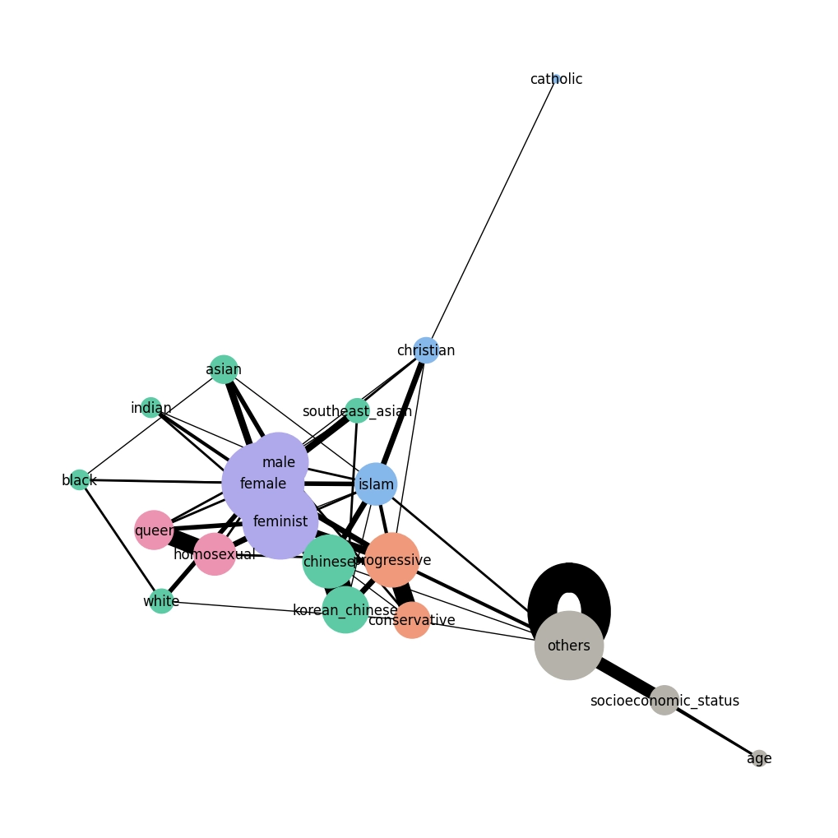
Figure 5. Co-targeting network of social identity groups in KOLD. Node size reflects weighted degree; edge thickness reflects co-occurrence frequency (N=278 comments).

The co-targeting network was constructed using NetworkX, based on 278 comments in which two or more target groups are mentioned simultaneously. Each node represents a social identity group, sized proportionally to its frequency in co-targeted comments. Each edge connects two groups that appear together as targets within the same comment, with edge thickness reflecting co-occurrence frequency.
This network captures the relational structure of offensive discourse: not who is attacked most often, but which groups are attacked together. As visible in the network, gender-related identities occupy the structural center, with politics, religion, race, and sexuality clustering around them.
2) Node level analysis
With the network constructed, we examine two node-level metrics: weighted degree, which captures how frequently each group appears in co-targeted comments, and betweenness centrality (BC), which measures how often a group serves as a structural bridge between otherwise separate parts of the network.
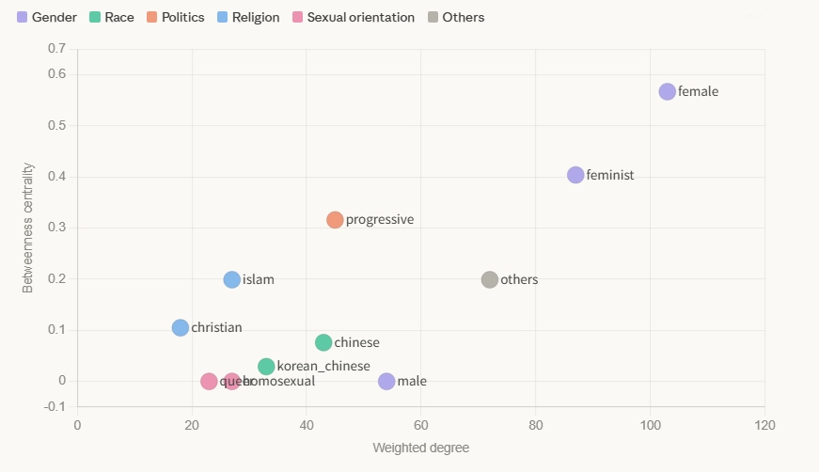
Figure 6. Weighted degree and betweenness centrality for target groups in the co-targeting network.

As shown in Figure 6, female ranks Female ranks first in both metrics (degree: 103, BC: 0.567), indicating that it is not merely a frequent target but a structural connector across multiple discourse domains. In contrast, male and homosexual show zero betweenness centrality despite having substantial degree scores. This distinction is important: these groups are actively co-targeted within specific clusters, but do not serve as bridges across the broader network.

3) Edge level analysis
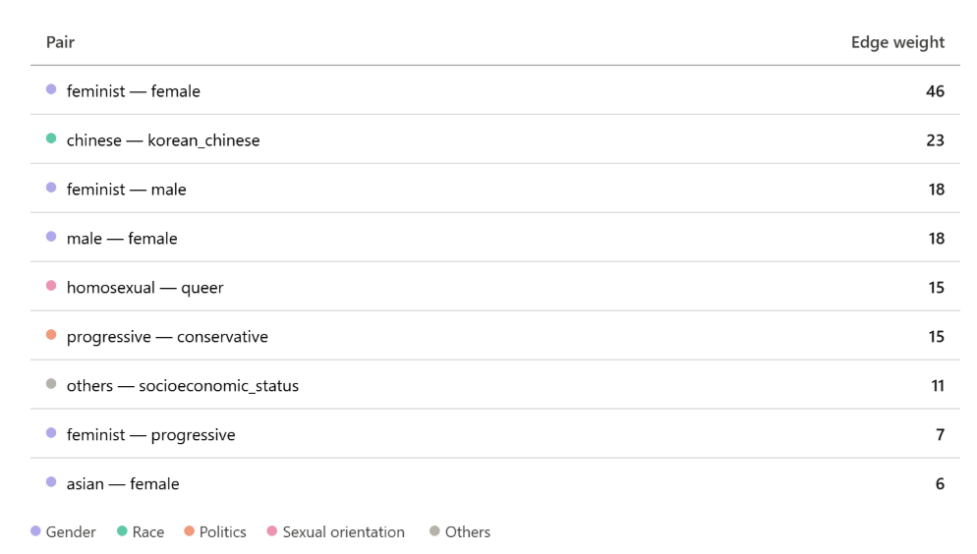
Figure 7. Top co-target pairs by edge weight. Colors indicate target group

Beyond individual node metrics, we examine edge weights to identify which group pairs are most frequently co-targeted. As shown in Figure 7, the strongest connection is feminist–female (46), indicating that attacks on feminist ideology are consistently intertwined with attacks on women as a gender identity. This is followed by chinese–korean_chinese (23), reflecting ethnicity-based co-targeting within the nationality cluster. Three structural patterns emerge from the edge data. First, a gender conflict triangle forms across feminist–female (46), feminist–male (18), and male–female (18), suggesting that offensive discourse in Korea is organized around a three-way gender conflict axis rather than a simple binary. Second, a political ideology axis appears through progressive–conservative (15) and feminist–progressive (7), linking gender and political identity within the same discourse. Third, sexuality-based co-targeting is captured by homosexual–queer (15), suggesting that attacks consistently conflate distinct LGBTQ+ identities. Together, these patterns suggest that co-targeting in Korean offensive discourse is not random but organized around identifiable conflict axes.
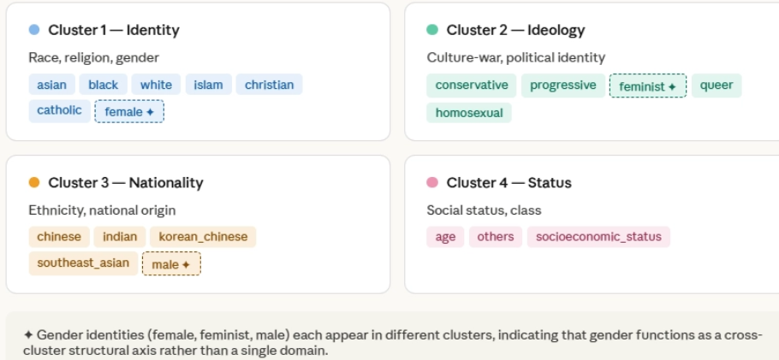
4) Cluster analysis
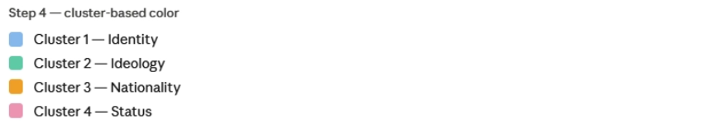
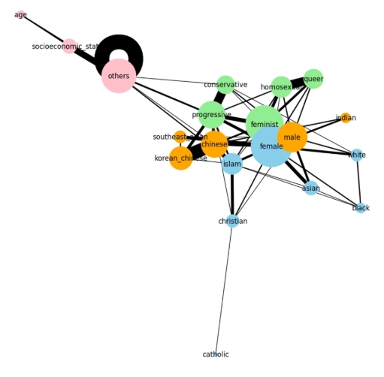
Figure 8. Four hate target ecosystems identified through clustering analysis. Gender identities (✦) appear across multiple clusters.
Figure 9. Co-targeting network with nodes colored by target group attribute. Node size reflects weighted degree; edge thickness reflects co-occurrence frequency.

As shown in Figure 8, clustering analysis reveals four distinct hate target ecosystems within the co-targeting network, suggesting that offensive discourse is not randomly distributed but organized around coherent identity conflict axes. Figure 9 visualizes the same network with nodes colored by target group attribute, confirming the cluster structure identified above.
Cluster 1 (identity) groups traditional social identity categories — asian, black, white, islam, christian, catholic, and female — reflecting conventional forms of discrimination organized around race, religion, and gender. Cluster 2 (ideology) brings together conservative, progressive, feminist, queer, and homosexual, forming a culture-war cluster where political ideology and sexual identity conflict converge. Cluster 3 (nationality) captures ethnicity- and origin-based targeting, grouping chinese, indian, korean_chinese, southeast_asian, and male. Cluster 4 (status) is organized around social position rather than identity, encompassing age, socioeconomic_status, and others.
Notably, gender does not belong to a single cluster. Female appears in the identity cluster, feminist in the ideology cluster, and male in the nationality cluster. This cross-cluster distribution indicates that gender functions not as one domain among many, but as a structural axis connecting multiple forms of offensive discourse. This structural organization sets the
stage for the next question. Offensive language is structured around conflicting social identities, rather than isolated taboo words.
If offensive discourse is structurally organized around interconnected identity networks, the next question is: how is each group linguistically attacked? The following analysis examines group-specific offensive framing patterns extracted from offensive spans.

- Q3. How Are They Attacked? Target-Specific Offensive Framing
1) Why not simple lexicon analysis?
As noted in the dataset description, offensive spans in KOLD are defined as the minimal yet sufficient text that annotators used to justify why a comment is offensive: not a list of swear words, but an annotated evidence span. This distinction has direct implications for lexical analysis. Offensive spans can include implicit expressions, sarcasm, affixes, and context-dependent phrases that only become offensive when read alongside the article title. Treating them as a simple token frequency list risks conflating lexical profanity with pragmatic framing, mistaking the surface word for the underlying discursive act. This analysis therefore focuses on the conceptual patterns embedded within offensive spans, asking not which words appear most often, but what framing strategies they enact.

- Token extraction and pattern discovery
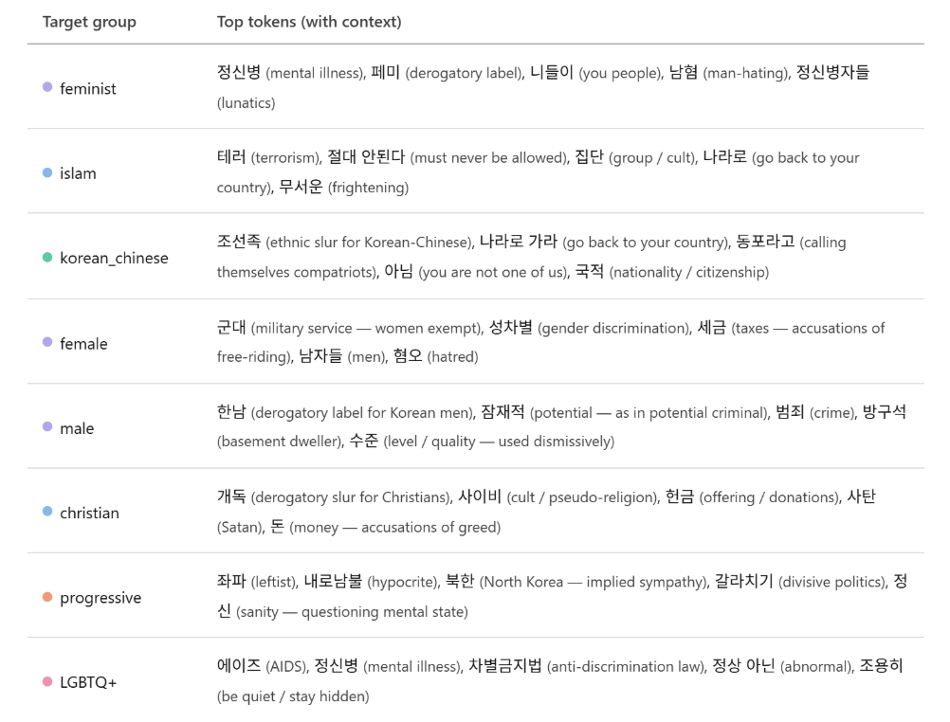
Figure 10. Most frequent offensive tokens per target group extracted from OFF_span, with contextual glosses.

We extract the most frequent tokens from the offensive spans of each target group to identify group-specific attack vocabulary. As shown in Figure 10, even at the raw token level, a clear pattern emerges: different groups are consistently associated with different words. Feminist-targeted comments repeatedly invoke 정신병 (mental illness); islam-targeted comments cluster around 테러 (terrorism) and exclusionary phrases; korean_chinese-targeted comments center on ethnic slurs and outsider framing; female-targeted comments revolve around 군대 (military service) and role-based discourse. These patterns suggest that offensive discourse in KOLD is not built around generic profanity, but around target–concept associations — each group attacked through a distinct and recurring set of lexical choices.

3) Concept taxonomy abstraction
The co-targeting network revealed that offensive discourse is structurally organized around interconnected identity clusters. But structure alone does not tell us everything, the next question is: how is each group linguistically attacked? This section examines group-specific offensive framing patterns extracted from offensive spans in the KOLD dataset.

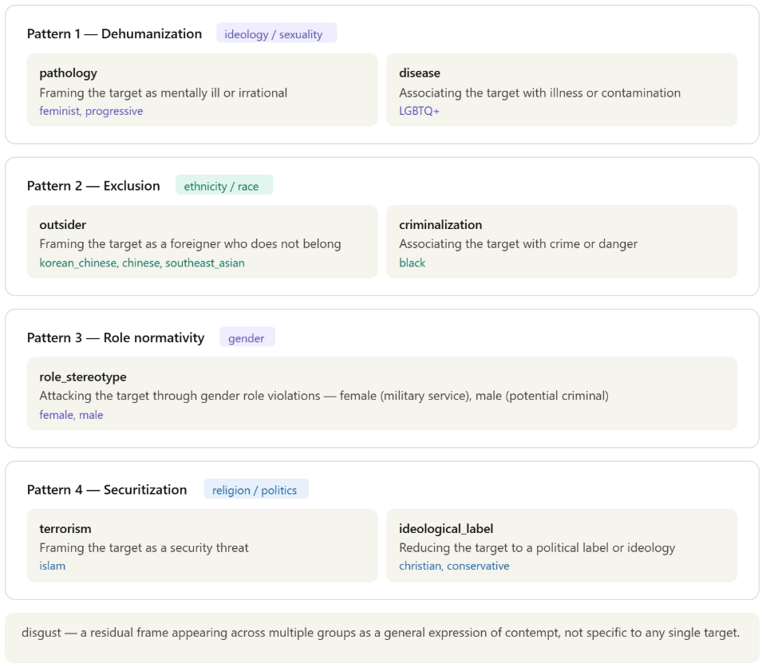
To move beyond surface-level token frequency, we normalize offensive tokens into conceptual categories and examine the distribution of attack frames across target groups. This abstraction reveals four dominant framing strategies, each further divided into more specific attack concepts.
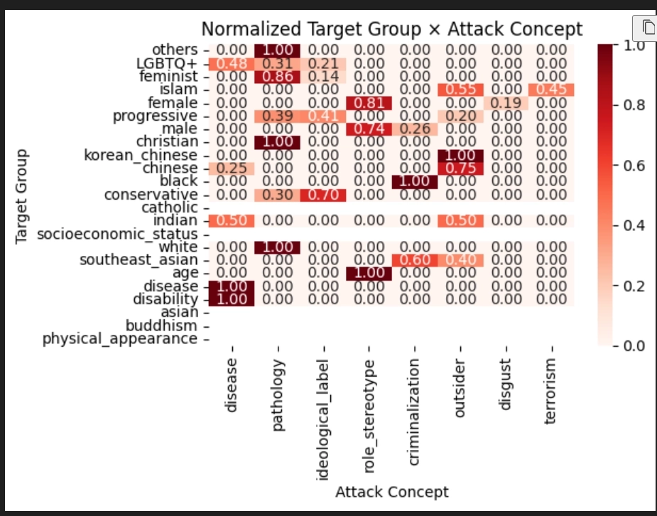
Figure 11. Four dominant offensive framing strategies identified through concept taxonomy abstraction.
Figure 12. Normalized distribution of attack concepts per target group. Values are normalized within each row to reflect the relative dominance of each frame.

As shown in Figure 12, the heatmap visualizes the normalized distribution of each attack concept per target group, confirming that offensive discourse follows target-specific framing strategies rather than generic profanity. Each row represents a target group; each column represents an attack concept. Values are normalized within each group to show the relative dominance of each frame.

Four patterns stand out. Ideological groups are pathologized: feminist shows the strongest pathology signal (0.86), and progressive follows (0.39), reflecting a recurring strategy of framing ideological opponents as mentally ill or irrational. Ethnic minorities are excluded: korean_chinese is almost entirely framed through outsider discourse (1.00), and black is predominantly criminalized (0.70) — notably importing Western racial bias frames into Korean online discourse. Gender groups are attacked through role normativity: female-targeted attacks are almost entirely role_stereotype (0.81), centering on military service exemption and perceived social free-riding, while male-targeted attacks mirror this pattern in the opposite direction. Finally, religious and political groups are securitized or ideologized: islam incorporates terrorism framing (0.45), while christian and conservative are reduced to ideological labels.
Taken together, offensive language in KOLD is not random profanity but follows target-specific framing strategies — ideological groups are pathologized, ethnic minorities are framed as outsiders, gender groups are attacked through role stereotypes, and religious groups are ideologized or securitized. Critically, the cluster structure identified in Q2 is confirmed linguistically here: the ideology cluster maps onto pathology framing, the nationality cluster onto outsider framing, and the identity cluster onto role stereotype and securitization frames.

- Conclusion and Characteristics of Korean Offensive Discourse
We identify korean offensive discourse is predominantly ideologically driven rather than identity-based, gender functions as a structural axis connecting multiple conflict domains, and attack frames reflect both locally generated social tensions and imported Western biases. These three characteristics distinguish Korean offensive language from other language datasets (English-language datasets such as HateXplain) and reveal the deep entanglement between language and sociopolitical structure.

Overall structure
This analysis examined Korean offensive language across three dimensions: who is attacked, which groups are attacked together, and how they are attacked. Taken together, the findings reveal that offensive discourse in Korean online spaces is not a collection of random insults but a structured system of identity- and ideology-based framing strategies, deeply shaped by Korea's specific sociopolitical context.

Ideology over identity
The most striking departure from English-language datasets is the dominance of ideology-based targets over identity-based ones. While African and Jewish communities top the rankings in HateXplain, feminist ranks first in KOLD, followed by progressive and LGBTQ+. This reflects a fundamental characteristic of Korean online discourse: attacks are directed less at who someone is and more at what they believe. Offensive language functions not merely as discrimination against a demographic group, but as a weapon in ideological conflict — a pattern consistent with the intensification of Korea's culture war discourse since the mid-2010s.

Gender as the central battleground
Gender does not function as a single domain in Korean offensive discourse — it is the structural axis around which multiple conflict dimensions converge. Female, feminist, and male each appear in different network clusters, yet female holds the highest betweenness centrality (0.567), connecting race, religion, ideology, and sexuality within a single discourse network. The strongest co-targeting pair is feminist–female (46), forming a gender conflict triangle with male. This suggests that in Korea, gender conflict is not a bilateral opposition between men and women, but a three-way ideological confrontation mediated by the category of feminism — a structure unique to the Korean sociopolitical landscape.

Attack frames: locally generated and imported
Several framing patterns are uniquely Korean. Female-targeted attacks center on military service (군대) — a frame that could only emerge in a society with mandatory male conscription, where exemption becomes a site of contestation. Male-targeted attacks deploy 한남 (hannam), a derogatory label with no direct equivalent in other languages, crystallizing Korea's gender war into a single lexical item. Progressive-targeted attacks frequently invoke North Korea, embedding Cold War ideological residue into contemporary online discourse. Korean-Chinese targets are framed as outsiders (outsider frame: 1.00) despite shared ethnic origins, reflecting Korea's exclusivist ethnic nationalism — the contradiction between ethnic kinship and civic exclusion made visible in language. Not all frames are locally generated, however. The criminalization of black targets (0.70) closely mirrors Western racial bias patterns, despite the relatively small Black population in Korea. This suggests that offensive framing is not always rooted in direct social experience — prejudice frames can be culturally transmitted through media and global internet culture, imported into contexts where they have little empirical grounding. Korean offensive discourse thus operates on two levels simultaneously: frames that are deeply native to Korean society, and frames that arrive from outside and take root in local language.

Cross-validation and closing
The structural findings of Q2 and the linguistic findings of Q3 converge: the ideology cluster maps onto pathology framing, the nationality cluster onto outsider framing, and the identity cluster onto role stereotype and securitization frames. Structure and language tell the same story. Korean offensive discourse is organized not around isolated taboo words, but around a network of identity conflicts where gender, ideology, ethnicity, and religion intersect — and where the lexicon of attack is as culturally specific as the society that produced it.

- References
Hagberg, A., Swart, P., & Chult, D. (2008). Exploring network structure, dynamics,
and function using NetworkX. Proceedings of the 7th Python in Science Conference, 11–15.
Jeong, Y., Oh, J., Lee, J., Ahn, J., Moon, J., Park, S., & Oh, A. (2022). KOLD: Korean Offensive Language Dataset. arXiv:2205.11315
Mathew, B., Saha, P., Yimam, S. M., Biemann, C., Goyal, P., & Mukherjee, A. (2021). HateXplain: A benchmark dataset for explainable hate speech detection. Proceedings of the AAAI Conference on Artificial Intelligence, 35(17), 14867–14875.

